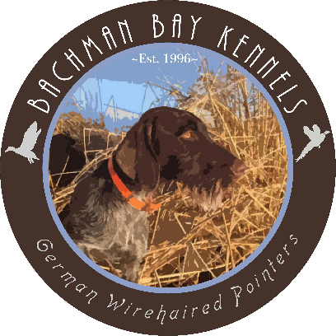
Bachman Bay Outdoors LLC
Dominic Bachman
PO Box 3022 Princeton, OR 97721
www.bachmanbaykennels.com

STUD SERVICE CONTRACT
VC HRCH CH BACHMAN BAY IMMOBULUS NA1 UT1

Call Name: “Sileaux”
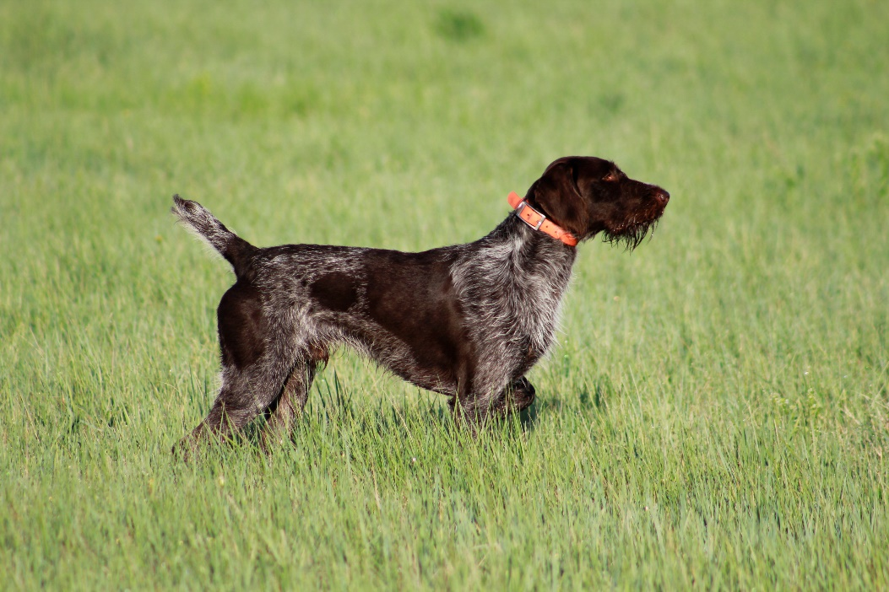
AKC Reg #: SS18280905
NAVHDA#: GW-012151
OFA Hips: Excellent
PennHip: rt. 0.26 lf. 0.27
Weight: 60lbs
Height: 25”
Elbows: Normal
CERF: Normal
Thyroid: Normal
Cardiac: Normal
DNA Furnishings Test: Ff
DNA Embark: Clear
Coat: Dense/Harsh
Bite: Normal
CHIC#: 182362

Stud Fee: Fee paid in full when bitch delivers at least three live pups. (half fee due if less than three) Fee must be paid before registration will be signed. Fee is $2500 or the cost of one puppy whichever is higher.

GENERAL CONDITIONS

Bitch to be bred must have field/working title. Stud caretaker guarantees a live litter of at least three puppies. We suggest all puppies be sold with limited registration. We expect all litters to improve the breed and your own program. All puppy owners should be strongly encouraged to test their puppies in the NAVHDA Natural Ability test, or in a venue of their choosing, at minimum. If dam owner is not breeding for the purpose of bettering the breed/their program than BBK reserves the rights to not breed to them again. Our goal is to be getting NAVHDA breeders awards or have multiple pups tested in other venues. Please help us achieve those goals by ensuring pups are going to testing/trialing homes.

BREEDING OPTIONS
Currently live cover is the best breeding option. Please coordinate ASAP when you think your Bitch will come into heat. Bitch must be transported to the stud in Mandan, ND or wherever the dog is at time of breeding. A fee of $25 per day will be charged for hosting the bitch if required. Payment for hosting is due at the time of breeding.

CLEARANCES
Bachman Bay requires all bitch’s owners to provide copies of OFA Thyroid and OFA/Penn Hip Certification. In addition, we recommend bitches have Elbows, Cardiac, and Eye clearances. In the case of a natural breeding, it is required we receive a copy of a negative Brucellosis prior to bitch arriving at stud. We would also appreciate a photograph and pedigree of the bitch, and a list of titles for our records.

Stud Dog Owner: Bitch Owner:
Catrina Terry
1101 2nd ave NW 58554
Mandan, ND
Catrina Cell 701-319-0585
Breeder/Co-owner
Dominic Cell 530-708-2141
Bachmanbaykennels@gmail.com

Bitch Owner Name:_______________________ Date:________

